Software Design and Development

ENG501 Assessment 3 Report

Model Mapping Documentation

Table of Contents
1. Introduction
2. Part A: Domain Class Model to ER Model Mapping
3. Part B: ER Model to Domain Class Model Mapping
4. Assumptions and Design Decisions
5. Conclusion

1. Introduction
This report documents the mapping process between Domain Class Models and Entity-Relationship Models (ERM) for two distinct systems: - A Rent-A-Car system (Domain Class to ERM mapping) - A Student Enrollment system (ERM to Domain Class mapping)
The document includes the mapping processes, design decisions, assumptions made, and detailed explanations of the relationships and structures implemented.

2. Part A: Domain Class Model to ER Model Mapping

2.1 Source Domain Class Model
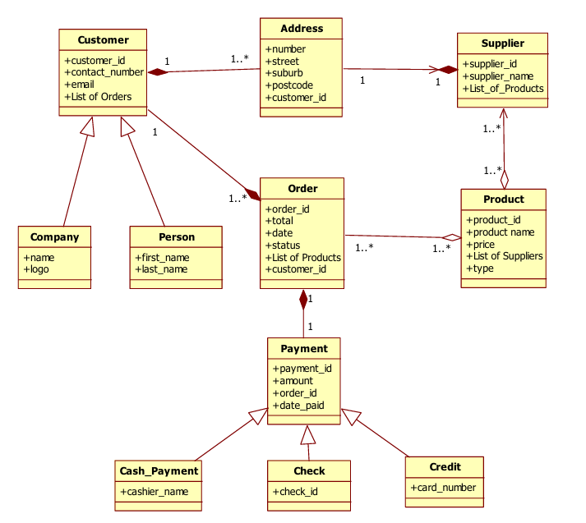
Model for Rent-A-Car System

2.2 Resulting ER Mode

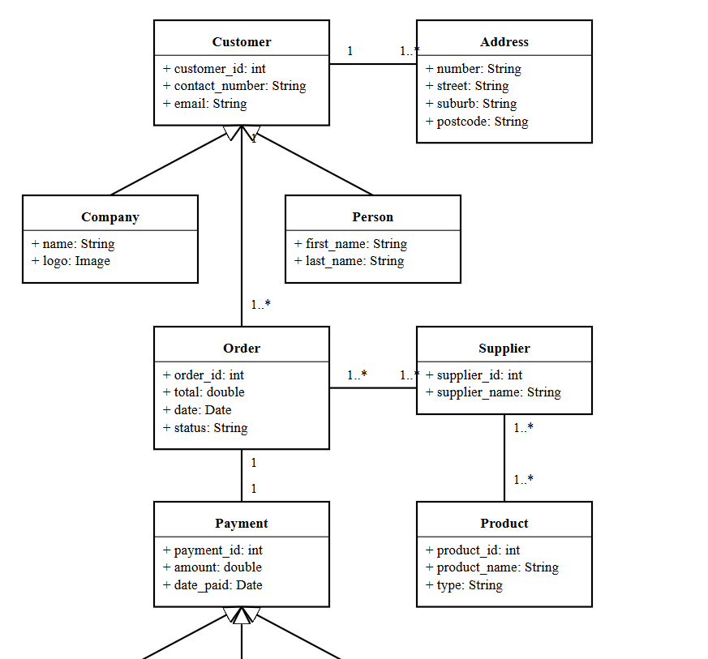

( Detailed modell attached separately in the Zip)

Figure 2: Mapped ER Model for Rent-A-Car System

2.3 Mapping Details

2.3.1 Entity Mapping
1. Customer Entity
– Primary entity with customer_id as PK
– Attributes: contact_number, email
– Serves as parent entity for Person and Company
2. Person Entity
– Inherits from Customer via shared PK
– Attributes: first_name, last_name
– customer_id serves as both PK and FK
3. Company Entity
– Inherits from Customer via shared PK
– Attributes: name, logo
– customer_id serves as both PK and FK
4. Order Entity
– Independent entity with order_id as PK
– Attributes: total, date, status
– FK: customer_id referencing Customer
5. Product Entity
– Independent entity with product_id as PK
– Attributes: product_name, price, type
6. Payment Entity
– Parent entity with payment_id as PK
– Attributes: amount, date_paid
– FK: order_id referencing Order

2.3.2 Relationship Mapping
1. Customer-Order Relationship
– One-to-many (1..*)
– Implemented via FK in Order table
– Mandatory participation from Order side
2. Order-Product Relationship
– Many-to-many (..)
– Implemented via junction table ORDER_PRODUCT
– Composite PK: order_id + product_id
3. Product-Supplier Relationship
– Many-to-many (..)
– Implemented via junction table PRODUCT_SUPPLIER
– Composite PK: product_id + supplier_id
4. Payment Inheritance
– Three child entities: Cash_Payment, Check, Credit
– Implemented using shared primary key strategy
– Each child table has payment_id as both PK and FK

3. Part B: ER Model to Domain Class Model Mapping

3.1 Source ER Model
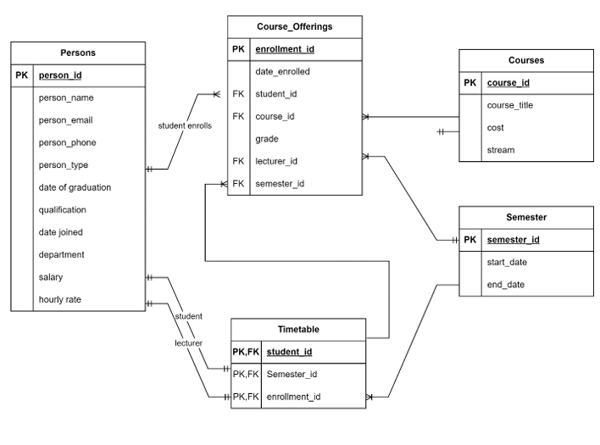

3.2 Resulting Domain Class Model
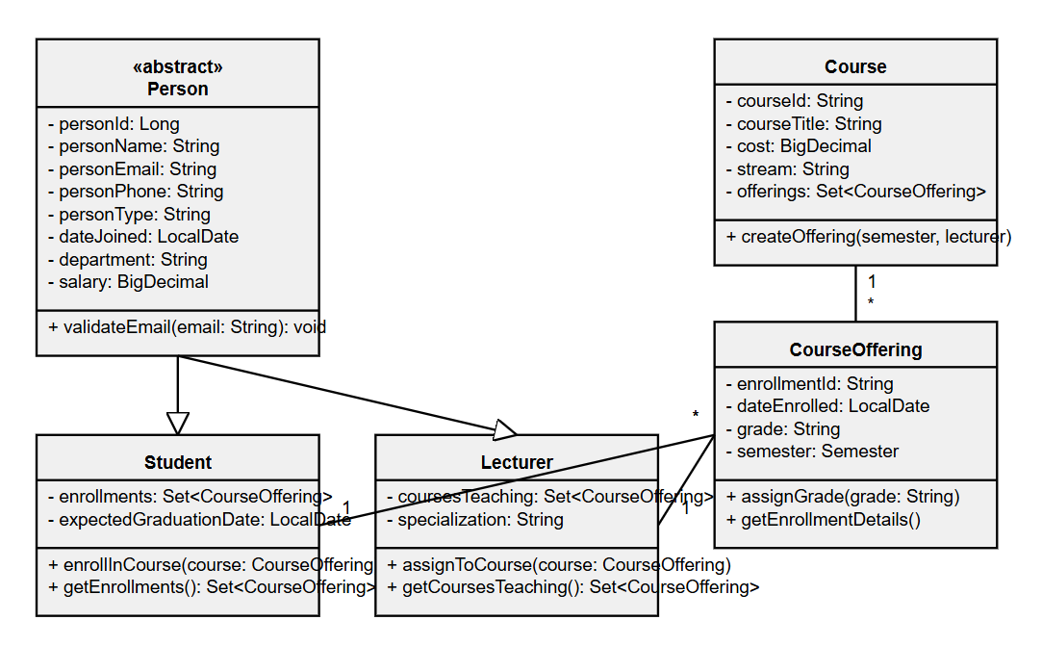\
( More detailed model is attached in the Zip )
Figure 4: Mapped Domain Class Model for Student Enrollment System

3.3 Mapping Details

3.3.1 Class Mapping
1. Person Class
class Person {
private int personId;
private String personName;
private String personEmail;
private String personPhone;
private String personType;
private Date dateOfGraduation;
private String qualification;
private Date dateJoined;
private String department;
private double salary;
private double hourlyRate;
}
2. Course Class
class Course {
private String courseId;
private String courseTitle;
private double cost;
private String stream;
}
3. CourseOffering Class
class CourseOffering {
private String enrollmentId;
private Date dateEnrolled;
private String grade;
private String studentId;
private String courseId;
private String lecturerId;
private String semesterId;
}

3.3.2 Relationship Mapping
1. Person Inheritance
– Abstract Person class with Student and Lecturer subclasses
– Inheritance based on personType attribute
– All common attributes in parent class
2. Course-CourseOffering
– One-to-many relationship
– Course (1) — (*) CourseOffering
– Navigable from both ends
3. Semester-CourseOffering
– One-to-many relationship
– Semester (1) — (*) CourseOffering
– Bidirectional navigation

4. Assumptions and Design Decisions

4.1 General Assumptions
1. Primary Keys
– All IDs are assumed to be system-generated
– String IDs represent business-meaningful codes
– Integer IDs represent system-generated sequences
2. Null Values
– Required fields implemented as NOT NULL
– Optional relationships allow NULL foreign keys

4.2 Part A Specific Assumptions
1. Inheritance Implementation
– Used shared primary key strategy for all inheritance
– Assumes single inheritance (no multiple inheritance)
2. List Attributes
– Implemented via junction tables
– No array or collection storage in base tables

4.3 Part B Specific Assumptions
1. Person Types
– personType field determines Student/Lecturer classification
– All person attributes relevant to both types
2. Timetable Implementation
– Serves as an association class
– Maintains scheduling information
– Links CourseOffering with Semester

5. Conclusion
The mapping process successfully transformed: - Domain Class Model to ER Model for the Rent-A-Car system - ER Model to Domain Class Model for the Student Enrollment system
Both mappings preserve: - Data integrity - Relationship constraints - Business rules - System functionality
The resulting models are ready for: - Database implementation (ER Model) - Object-oriented development (Domain Class Model)

